DEPARTMENT OF ENGLISH
ACTIVITIES/PARTICIPATION DURING 2021-22

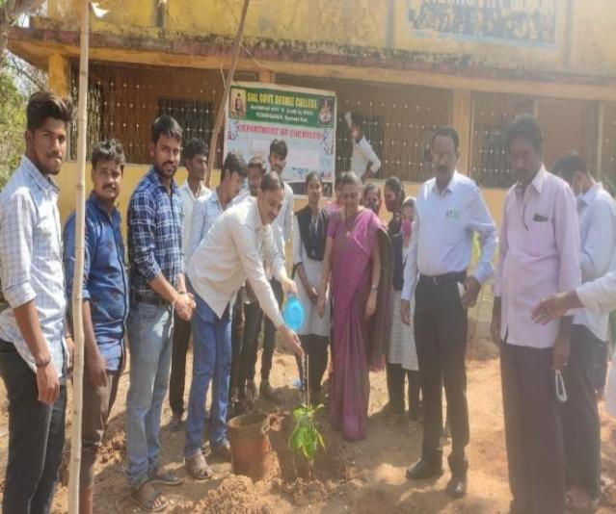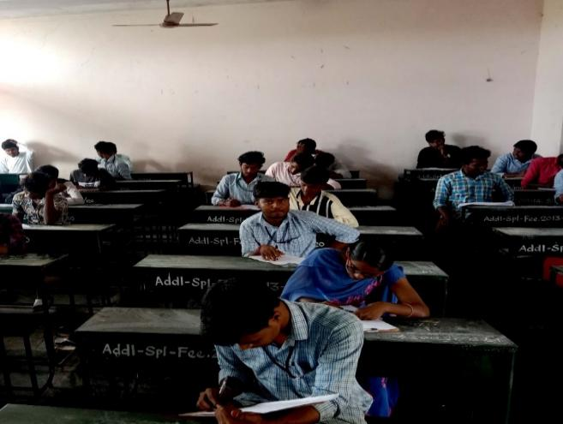
Participation in Environmental Day Assignment

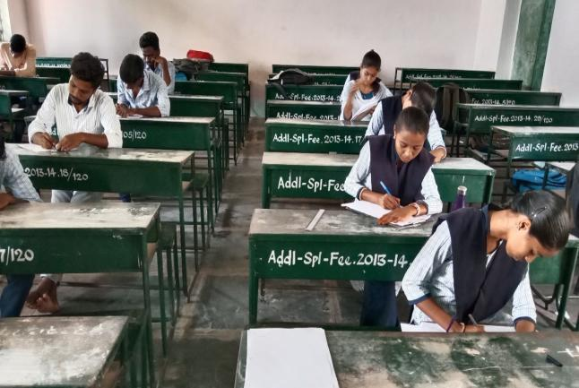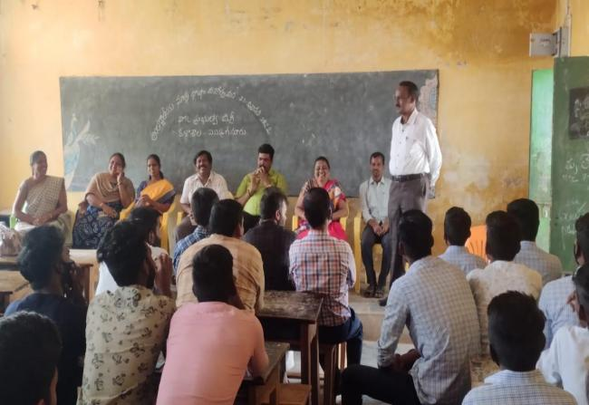
Mid Semester Examination Participation in Mother Tongue Day 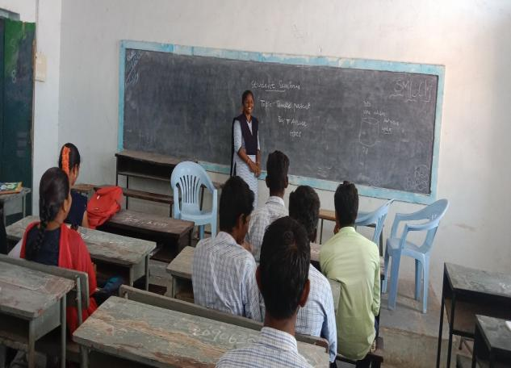 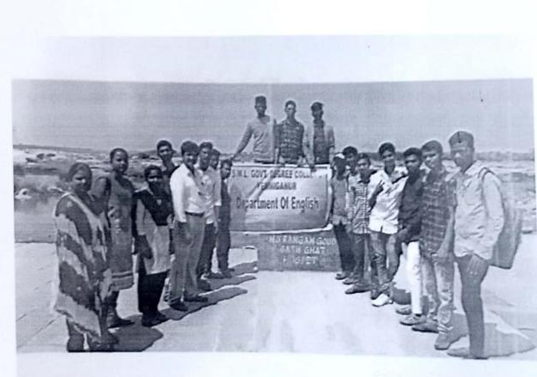
Student Seminar Field Trip to Mantralayam Temple

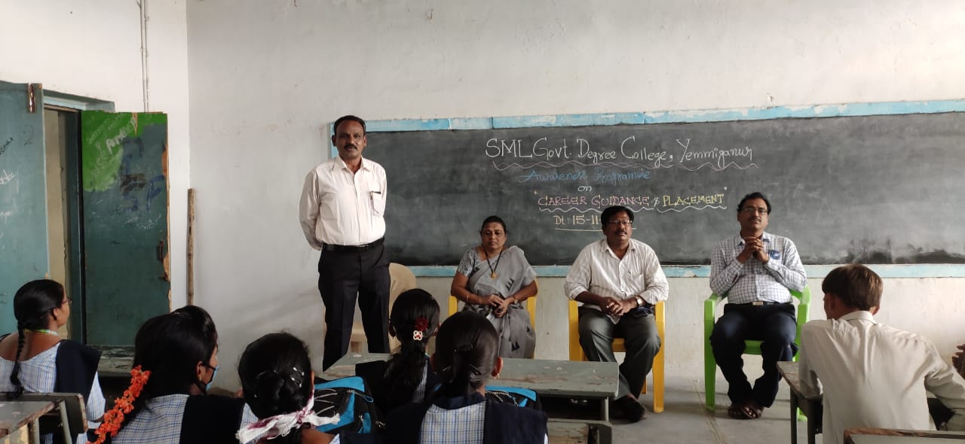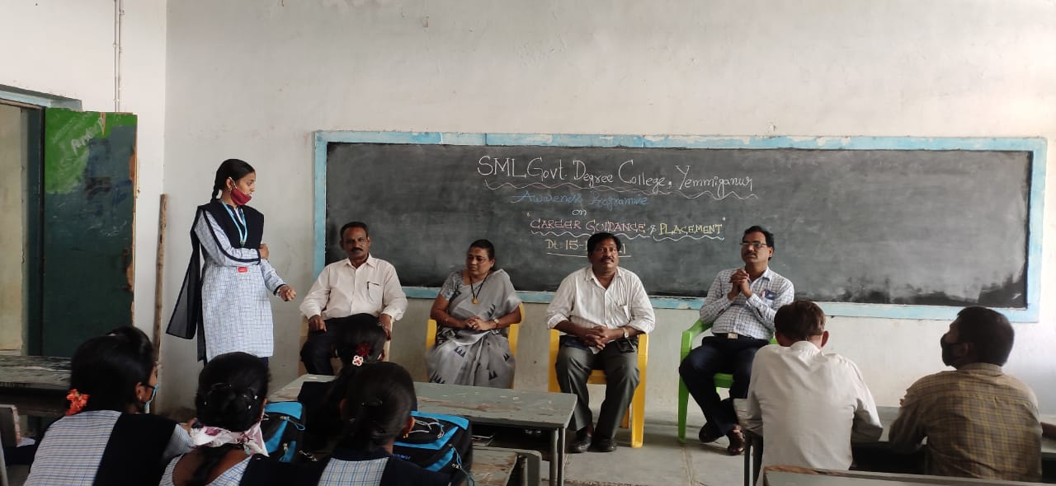
Awareness Progromme on Vote of Thanks By
Career Guidance and Placement V.Roopa Lavanya I BA

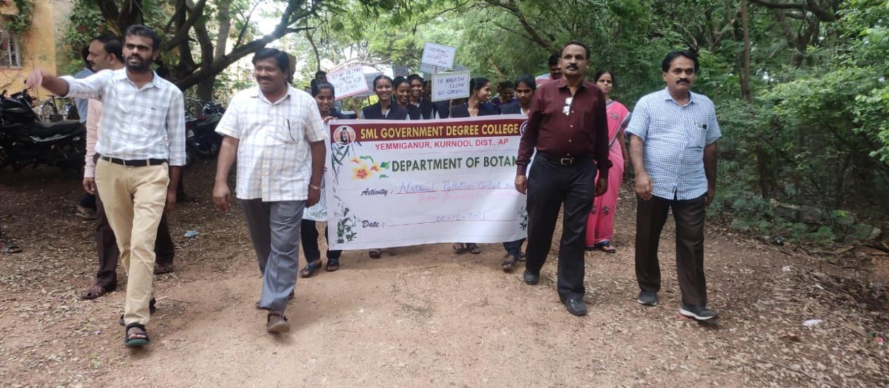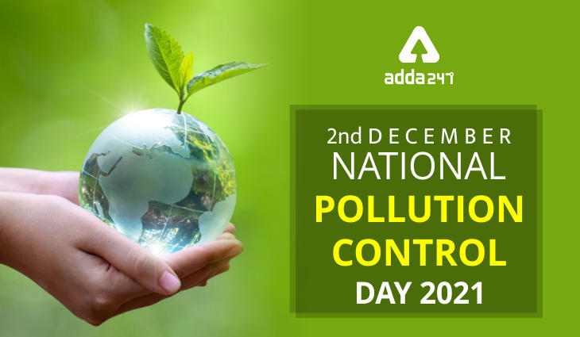
Participation in
National Pollution Control Day

